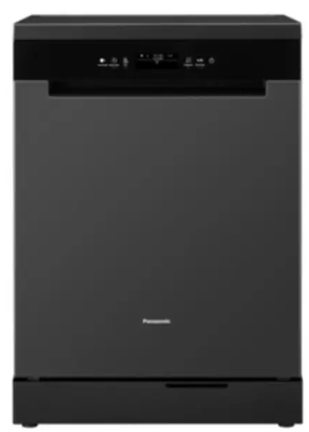

Panasonic Dishwasher
Rs.195,000
Panasonic dishwasher DW-BFD12J supports 12 place settings, sensor drying, adjustable racks, and low-water dish cleaning in a quiet stainless-steel build.

Specifications
- Model: DW-BFD12J
- Capacity: 12 Place Settings
- Water Use: 7 Liters per cycle
- Noise Level: 42 dB(A)

Key Features
- 5 auto programs
- Sensor dry
- Auto open drying
- Adjustable racks

